Magic Mountains
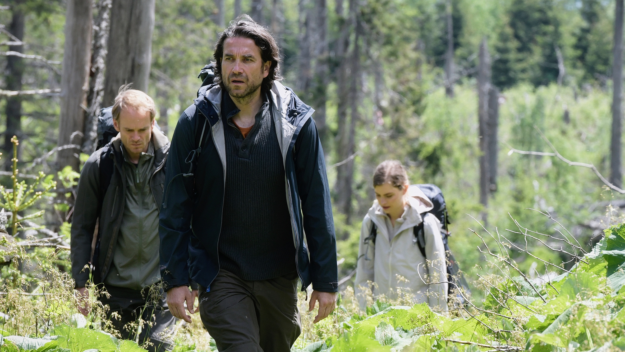

A FILM BY URSZULA ANTONIAK

FAMILY AFFAIR FILMS

Magic Mountains

Lex (Thomas Ryckewaert), a Dutch writer of popular novels, has money and fame but no peace of mind since Hannah (Hannah Hoekstra) left him years ago. Lex wants to close the relationship in a symbolic gesture and asks her to go with him to the mountains for a last climb together. Voytek (Marcin Dorocinski) a professional mountain guide, is hired to take the two to the remote starting point and leave them there. But Voytek senses that Lex is unstable and refuses to leave Hannah alone with him.

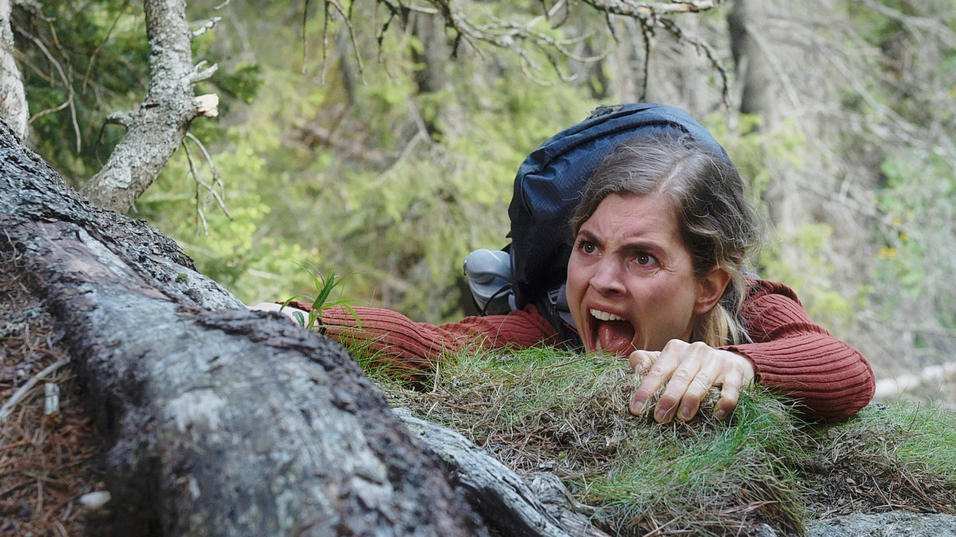

Cast: Hannah Hoekstra, Thomas Ryckewaert, Marcin Doroncinski

Writer & Director: Urszula Antoniak

Producer: Family Affair Films – Floor Onrust

Director’s note Urszula Antoniak

We don’t have rituals for closing relationships. After we are left by the person who was the center of our life, there is no funeral that will symbolically make him or her pass and leave our life. In ‘tinderised’ times, people move in-and-out of relationships in search of happiness ‘leaving behind’ is part of the search. Lex needs to give a meaningful end to his relationship with Hannah, once his partner in life and climbing. Their last climb together, his symbolic gesture to close his past with her, will be the start of his new life. “Help me to forget you” - Lex almost obliges Hannah and I think he is right in that. Relationships come with responsibility.
Mountain climbing and relationships have similar symbolic. Both are based on trust. “She was always second.” - says Lex to Voytek about Hannah. Both in life as in climbing Hannah was always following Lex. “Now she goes first” - answers Voytek and he lets Hannah climb alone as anticipation of the final countdown between her and Lex.
In MAGIC MOUNTAINS the action sequences belong to her, rather than him. Actress Hannah Hoekstra demanded to do the climbing scenes herself. Like her character in the film, she is unstoppable and unbeatable.

CV Acteurs

Hannah Hoekstra – Hannah
Hannah Hoekstra (1987) graduated in 2010 from the Amsterdam Theatre School. Hannah was selected as Berlinale Shooting Star (promising talent) in 2017. She won awards for Best Actress for her leading roles in Hemel (Sacha Polak – Berlinale 2012) and De Helleveeg (André van Duren – 2016). In 2019 Hannah won the Theo d’Or, award for Best Theatre Actress in The Netherlands for her role as drug addict Emma in People, Places and Things.

Thomas Ryckewaert – Lex
Thomas Ryckewaert (1979) graduated in 2006 from drama school at the Antwerp Conservatory. He is known from his leading role in the international drama series The Spiral, that was nominated for an Emmy award. In 2017, Thomas was nominated for Best Actor for his role in Waldstille (Martijn Maria Smits – San Sebastian 2016). He also starred in the feature Cobain (Nanouk Leopold – Berlinale 2018).

Marcin Dorocinski - Voytek
Marcin Dorocinski (1973) is a Polish film, television and stage actor. He is well known for his portrayals of conflicted, troubled characters. He is widely regarded as one the most talented and respected Polish actors. Dorocinski gained critical acclaim in the early 2000s, culminating in his Zbyszek Cybulski's Award for Best Young Polish Actor (2005), Polish Eagles nomination for Best Actor (2008) followed by Golden Lions Award as best supporting actor for Reverse (2009) and best actor in a leading role for Rose (2011). Dorocinski gained worldwide acclaim for his role in TV series Into deep water (52 MonteCarlo Television Festival nominee for Best Actor), won Best Actor award at Porto Film Festival and International Film Festival of India for Rose (2012)

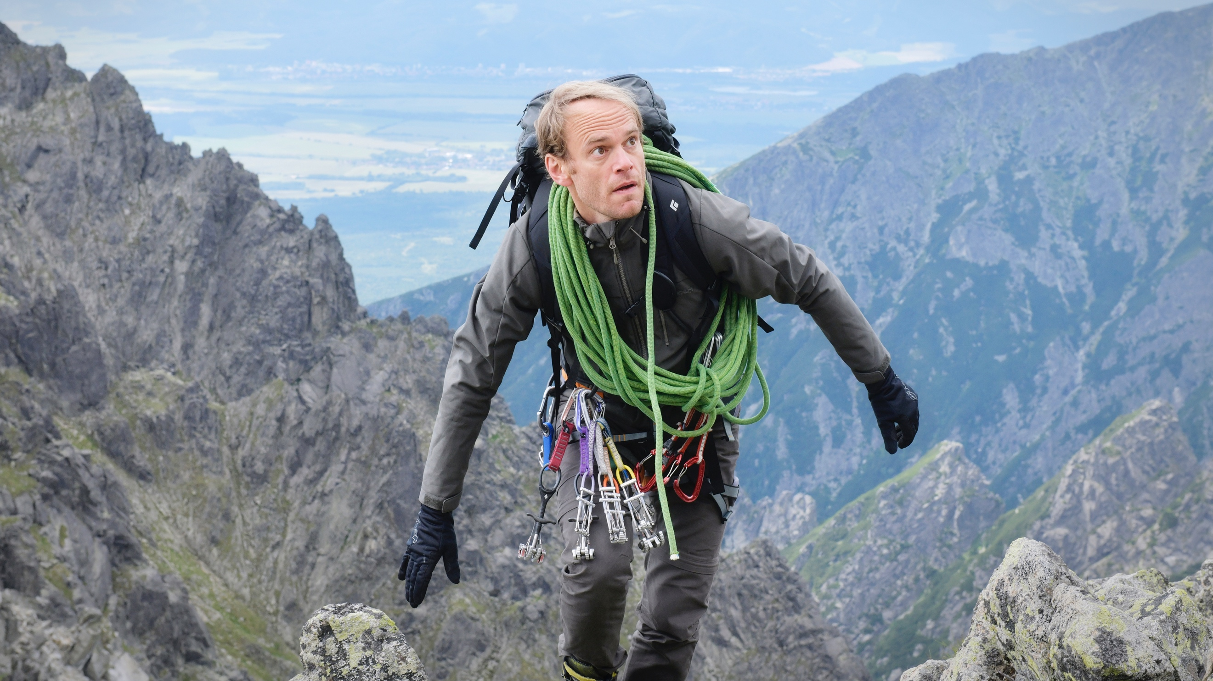

CV Makers

Urszula Antoniak is an established writer and director. Her feature debut Nothing Personal (2009) was nominated for two European Film Academy Awards (2010), won 6 prizes including the prize for best debut film and Best Actress in Locarno. Code Blue (2011) was selected for the Cannes’ Director’s Fortnight. Lead actress Bien de Moor won various international prizes for best actress. Beyond Words (2017) had its international premiere in Toronto and its European premiere in competition in San Sebastian.

Family Affair Films produced the acclaimed films Light as Feathers (Toronto 2018), Beyond Words (Toronto and San Sebastian 2017), the family film Life according to Nino (best film Cinekid 2014) and Code Blue (Cannes 2011). Bloody Marie by Guido van Driel & Lennert Hillege premiered during the International Film Festival Rotterdam 2019 and will have its US release in November 2019. Family Affair Films is currently developing Urszula Antoniak's fifth feature film Stranger and Steve McQueen's documentary The Occupied City.

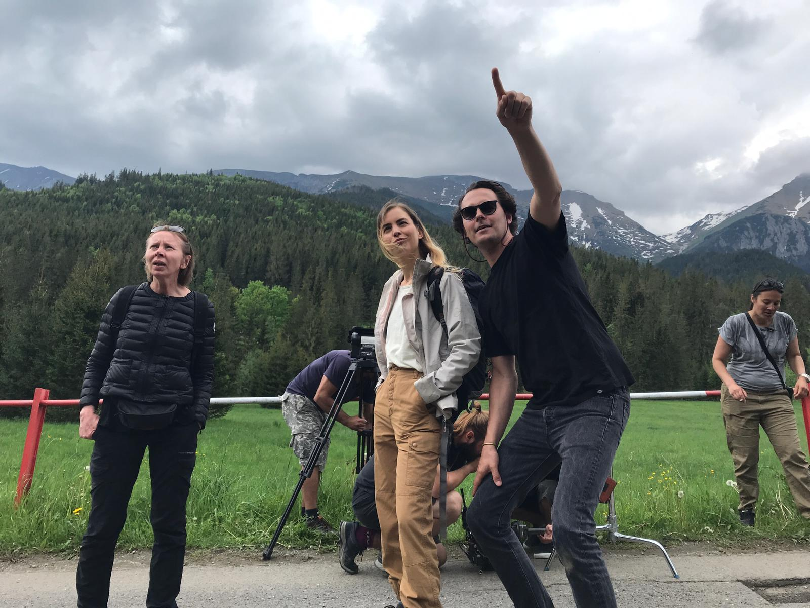

Urszula Antoniak, Hannah Hoekstra and Lennert Hillege on set in Slovakia.

CREDITS

Hannah Hannah Hoekstra

Lex Thomas Ryckewaert

Voytek Marcin Dorociński

Director of Photography Lennert Hillege, NSC

Casting Rebecca van Unen

Climb & safety supervisor Andrzej Marcisz

Make up & Hair Ria Pontikis

Costume design Sara Hakkenberg & Louka Hoogendijk

Editor Milenia Fiedler, PSM

Composer Ethan Rose

Sound design Mark Glynne

Line producer Marianne van Hardeveld

Co-producer NTR Marina Blok
Co-producer Arina Film Silvia Panáková

Producer Floor Onrust

Writer & director Urszula Antoniak

